***BEEE EVALUATION***

**Aim:**

**Design a dice that displays a A. Red background when 6 comes up B. Green background when 4 comes up . C. Blue background when 2 comes up.**

**Apparatus used:**

Arduino, breadboard, connecting wires, LDR, resistor, LED.

**Principle used:**

A **seven segment display** consists of **7** LEDs arranged in the form of Square '8' and a single **LED** as dot character. ... A **7 seven segment display** is an electronic **display**, which **displays** 0-9 digital information. They are available in common cathode mode and common anode mode.

**Circuit Diagram:**

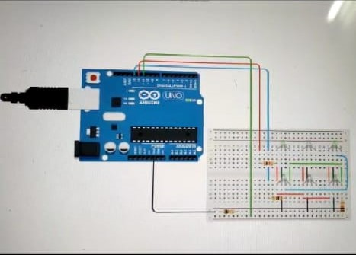

**Precautions used:**

1. Always use the arduino without plugging it.
2. Don’t touch the energized wires and equipments.

**Source Code:**

**int led 1=13;**

**int led 2=11;**

**int led 3=12;**

void setup()

{

pinMode(led 1,OUTPUT);

pinMode(led 2,OUTPUT);

pinMode(led 3,OUTPUT);

}

void loop()

{

digitalWrite(led 1,HIGH);

delay(1000);

digitalWrite(led 1,LOW);

delay(1000);

digitalWrite(led 2,HIGH);

delay(1000);

digitalWrite(led 2,LOW);

delay(1000);

digitalWrite(led 3,HIGH);

delay(1000);

digitalWrite(led 3,LOW);

delay(1000);

**Problems faced:**

1. Connecting the equipments in right phases.
2. Problem faced in uploading the code to the board.
3. Errors in source code.

**Solutions to problems faced:**

1. By connecting the anode of the LED to the ground.
2. Correcting the loops initialisation.